

**Pre-School Admission Policy 2023-2024**

Bramley Church of England Infant and Nursery School

|  |  |
| --- | --- |
| **Policy effective from** | March 2021 |
| **Approved by** | Resources Committee |
| **Last reviewed on** | June 2023 |
| **Next review due by** | June 2024 |

|  |  |  |  |
| --- | --- | --- | --- |
| **Version history** | | | |
| **Version** | **Description of change** | **Author** | **Approved** |
| 3.0 | Increase of deposit | Shona Taylor | Admission committee |
| 2.0 | Removal of reference to Holy Trinity on supplementary page, refer instead to a church of England church. | Shona Taylor | Full governing body |
| 1.0 | Formatting  Change to wording re funded hours | Shona Taylor | Full governing body |

“Your word is a lamp to guide me and a light for my path” Psalm 119(105)

**Rooted in Christian Values,**

**Seek within,**

**Wonder why,**

**Reach out,**

**Aim high.**

## Bramley CofE Infant and Nursery School is a fully inclusive School that warmly welcomes families from all faiths or no faiths, communities, cultures and backgrounds. As a Church of England Aided School, we determine our own admission arrangements and our ethos. Our school vision reflects the close links the school has with the Church and Christian values and beliefs. This association is reflected in the School prospectus which is available on the school website, alongside details of our admission arrangements, these can be collected from the school office.

Children are admitted only in accordance with this policy and where places are available, in accordance with the below order of priorities.

The local authority has delegated children’s admission to the Governing Body. Admissions and session allocation are decided by the Headteacher. A final decision where places are oversubscribed rests with a panel of governors on behalf of the governing body in line with the over subscription criteria below.

In England all three and four year olds are entitled to up to 15 hours of funded early education and childcare a week for up to 38 weeks a year. This is to give children the opportunity to take part in planned learning activities, and help prepare them for school through the early learning goals set out in the [**Early Years Foundation Stage**](https://www.surreycc.gov.uk/people-and-community/families/education-and-learning-advice-for-families/early-learning/parents-guide-to-the-early-years-foundation-stage). This is a universal offer and is available to all children regardless of their family circumstances.

Since September 2017 the government has increased the number of funded hours for 3 and 4 year olds from 15 to 30 a week. However, this will only be made available to families where both parents are working (or the sole parent is working in a lone parent family) and each parent earns, on average, a weekly minimum equivalent to 16 hours at National Minimum wage (NMW) or National Living wage (NLW), and less than £100,000 per year. You can find further information about the eligibility criteria on our [**30 hours funded childcare for working parents**](https://www.surreycc.gov.uk/people-and-community/families/childcare/paying/30-hours-funded-childcare-for-working-parents) web page.

Parents/carers are welcome to request additional sessions above the allocations which they self-fund.

**Procedures for Bramley CofE Infant and Nursery School –**

Bramley CofE Infant and Nursery School operate during term-time only. Children are normally eligible for admission at the beginning of the first term **after** their third birthday, when they are eligible for their free 15 or 30 hours.

The maximum number of children in a session would not normally exceed 30; however, the Headteacher reserves the right to allocate further places during the academic year.

On occasions, where spaces are available it may be possible for a child to begin during the school term.

As far as possible the Pre-School will try to offer the days and sessions requested by a parent, but the oversubscription criteria will be used if sessions or days are oversubscribed.

Admission will be subject to an application being made; places being available and if appropriate, an agreement that the setting can cater for a child’s needs (see ‘priority need’).

**All 3 – 4 year olds are expected to attend for a minimum of 15 hours or 30 hours if parents are in receipt of funded hours, children can build towards this beginning with a minimum of 3 sessions. The School will apply to the local authority for the full 15 or 30 hours.**

Once a child’s hours are determined it is expected that the child will attend for their full hours. A parent may to decide to work towards their child’s full attendance over a period of time, however to ensure staff ratios can always be met, staffing and therefore funding will always be based on the full attendance of the child up to their fully funded hours. For this reason, apart from in exceptional circumstances (e.g. child residing in more than one home), it is not possible to split funding with another provider.

In the event that the school is unable offer fully funded hours then hours may be split but the parent must inform the school in writing of the name, address and hours claimed for at the other setting.

**Session Times for Pre-School -**

**Please note the school reserve the right to amend sessions times as required, a term’s notice will be given**.

Mornings: 8.30am - 11.30am

Morning including Lunch: 8:30-12:30pm

All day: 8.30am - 3pm

A hot lunch can be purchased or you can provide a packed lunch for your child. (No nuts, sweets or fizzy drinks)

Ad-hoc sessions may be available - please contact the school office to enquire, however it is not possible to swap pre-booked sessions.

**The Application Process**

Names are accepted onto the waiting list at any time. Parents/carers are asked to visit the School to view the Pre-School and then complete an application form.

Parents/carers will be notified a full term before their child is due to start of what days and hours have been allocated. Parents/carers must confirm within 2 weeks whether they still require the place. If a place is offered but no response is received within two weeks, the place will be offered to the next child on the Waiting List.

**A £50 deposit paid to secure the place, is payable at this point.** This will be refunded at when first invoice has been paid.

Families in receipt of Early years pupil premium (EYPP) who are unable to pay the deposit should speak to the finance assistant in confidence.

Parents/carers of children in the School’s nursery should contact the school at their earliest convenience but not less than a full term before their child moves to Pre-school to request hours.

When demand for places in the Pre-School department at Bramley Church of England Infant and Nursery School exceeds the number of places available, the Governors give priority for admission to children according to the oversubscription criteria set out below. Discussions with the professionals involved and representatives from Surrey may form part of this process.

The final decision on when a child is admitted, the number of hours a child is able to attend and his or her pattern of attendance, rests with the Headteacher.

**Fees**

An invoice will be sent at the beginning of each half term for that half term and payment must be made within 14 days of the invoice. If payment is not received, then the additional chargeable hours will be withdrawn, meaning your child will only be able to attend for their funded 15 or 30 hours.

We also accept payment by Childcare Vouchers – please ask us for details.

You will still be charged if your child does not attend any sessions including illness and holidays.

Charge for late collection will commence 10 minutes after agreed pick-up and will be £5 per 10 minutes or part thereof, late charges will be added to the next invoice.

Half a term’s notice is required in writing if you choose to leave the Pre-School or reduce the number of sessions.

**Admissions Criteria**

1. Looked After and previously Looked After Children (See Appendix A item 1)
2. Children with an exceptional medical/social condition which means they must attend Bramley Infant School Nursery rather than any other. (See Appendix A item 2)
3. Siblings, i.e. a child who will have a brother or sister at Bramley Church of England Aided Infant and Nursery School at the time of entry to the school nursery. See Appendix A item 3 and 5.
4. Children whose home address is within the Ecclesiastical Parishes of Bramley and Grafham. (See Appendix A, item 4 and Appendix C)
5. Children of families who can show membership of a Church of England Church within the Ecclesiastical Parishes of Bramley and Grafham. (Membership defined according to criteria detailed in Appendix B)
6. Children whose home address is outside the Ecclesiastical Parishes of Bramley and Grafham, who can show membership of another Church of England church. (Membership as defined according to criteria in Appendix B, See also Appendix A, item 4).
7. All other children whose parents wish them to attend the Nursery department at Bramley Church of England Aided Infant and Nursery School.

Should the school be oversubscribed within one of the above criteria; the distance from home to school will be the deciding factor. Those living closer to the school will receive the higher priority. The distance is measured in a straight line from the address point of the child’s home as set by Ordnance Survey, to the nearest school gate available for pupils to use. This is calculated using the Surrey County Council’s Geographical Information System. For blocks of flats, apartments or buildings where there may be multiple addresses with only one address point or where two or more applicants live at the same distance from the school, priority will be decided by an independent supervised lottery.

Where one or more children from a multiple birth are offered a place, but there are insufficient places for all children from the same multiple birth ranked consecutively, the school will offer each child a place.

**Withdrawal/refusal of Offers**

The Governing Body reserves the right to withdraw the offer of a place where a parent has made a fraudulent or intentionally misleading application which denied a place to another child, who would otherwise have been offered a place.

**Social/Medical Need**

Supporting evidence is required from a professional such a Consultant Doctor or registered health professional demonstrating why it is essential for the child to attend the Nursery school and the difficulties that would be caused if the child was unable to attend this School. This evidence must confirm the circumstances of the case and must set out why the School is the most appropriate school for the child.

**Waiting List**

Should there be more applications than there are places a waiting list for admission to the Pre-School classes will be maintained. Parents will have to ask to be put on the waiting list should they require a place at the Pre-School. Any places which become available are allocated as set out above.

Applications will be managed by the school and therefore parents should contact the school directly.

The Governors Admission Policy will apply throughout the course of the Academic year should places become available. The ‘Pool of Applicants’ for any applicable year groups will be assessed in strict compliance with this Policy.

***Appendix A***

1. **Children Looked After are**: children who are in the care of a local authority or provided with accommodation by a local authority in accordance with Section 22 of the Children Act 1989, e.g. fostered or living in a children’s home, at the time an application for a school is made; and children who appear (to the admission authority) to have been in state care outside of England and ceased to be in state care as a result of being adopted. A child will be regarded as having been in state care outside of England if they were accommodated by a public authority, a religious organisation or any other provider of care whose sole purpose is to benefit society.

***Previously Looked After Children:***children who have previously been in the care of a local authority or provided with accommodation by a local authority in accordance with Section 22 of the Children Act 1989 and who have left that care through adoption, a child arrangements order (in accordance with Section 8 of the Children Act 1989 and as amended by the Children and Families Act 2014) or special guardianship order (in accordance with Section 14A of the Children Act 1989);

*2.Applications in such circumstances must be supported at the time of application by documentary evidence from* *a Consultant, Doctor or registered health professional demonstrating why it is essential for the child to attend the Nursery school and the difficulties that would be caused if the child was unable to attend this Nursery school. Providing evidence does not guarantee that a child will be offered a place and in each case a decision will be made based on whether the evidence demonstrates that a priority placement should be made and whether the child’s needs can be met.*

*NB: All Surrey schools deal with more common medical conditions such as nut allergies, asthma, eczema and stress related symptoms.*

*3.‘Sibling’ – a brother/sister, half-brother/half-sister, step-brother/step-sister or adoptive brother/adoptive sister or foster children, living in the family unit at the same time in each case.*

*4.Home address – the child’s permanent address or in cases of shared custody, where s/he lives for the majority of the school week.*

*5. Parent – a natural, adoptive, step or foster parent or other legal guardian.*

***Appendix B***

***Definition of ‘Church membership’ (criteria 5 and 6)***

*1. An applicant who is a regular worshipper. This means a parent and/or child who worships once a month for at least one year immediately preceding the date of application. To accommodate difficult patterns of work and family relationships, account will be taken of weekday worship. The worshipper could be the child for whom the application is made or one or both parents/carers.*

*Applicants new to the area would need to provide evidence from a previous church or churches.*

*Note:*

*In the event that during the period specified for attendance at worship, the church has been closed for public worship and has not provided alternative premises for that worship, the requirements of these arrangements in relation to attendance, will only apply to the period when the church or alternative premises have been available for public worship.*

***Appendix C Parish Boundary***

[***https://www.achurchnearyou.com/***](https://www.achurchnearyou.com/)

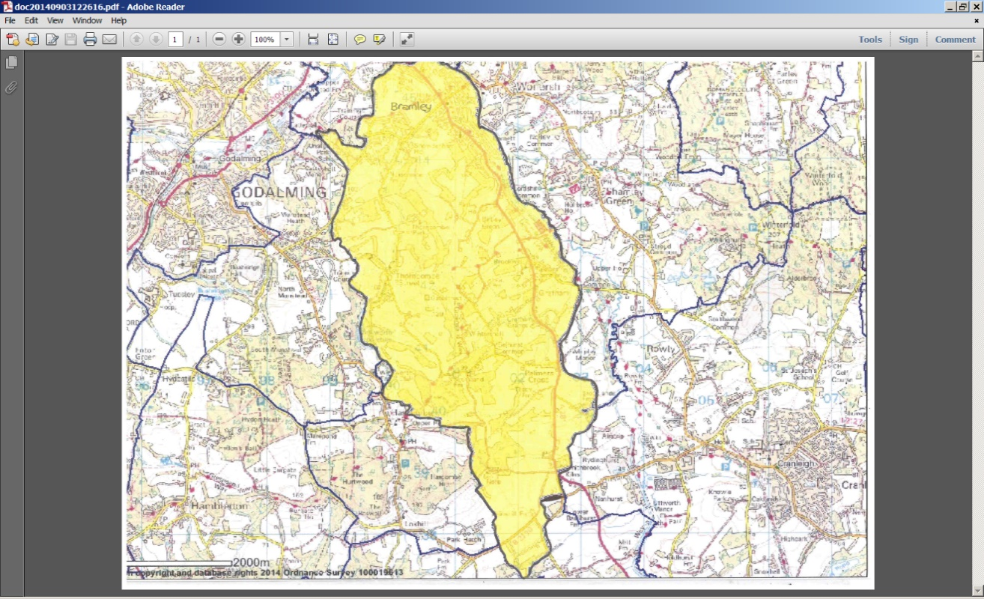

**Please note**

**Attendance at the Pre-School does NOT mean that a place is automatically available at Bramley Cof E Infant and Nursery School. A formal application for the infant school MUST be made via the Local Authority in accordance with the Infant School’s admission arrangements**.

**Bramley Church of England Infant and Nursery School**

***To be completed only if you are applying under criteria 5 or 6. Applicants are required to return this form to the school office in order to prioritise applications in the case of oversubscription.***

Name of Child………………………………………………………………………

Name of Parent/Guardian ….…………………………........................................

Address.……………………………………………………………………………...……………………………………………………………………………….

………………...…………………………………………………….……………………………………………………...…………………………………………….

Telephone Number…………………………………………..................................

Email…………………………………………………………………………….....................

Are you a regular worshipper (see criteria 5 and 6) a Church of England Church? Yes/No

Name of church…………………………………………..

Signature of Parent/Guardian…………………………………………………

Date………………………………………….

**The following section must be completed by the applicant(s) in conjunction with the Vicar or other appropriate church leader.**

I confirm that the above named meets the ‘Regular Worshipper’ criterion of worshipping at least once a month over a period of at least one year immediately preceding the date of this application.

Name of Vicar…………………………………………………….........................................

Signature of Vicar…………………………………………………………

Date……….……………………………….

Church stamp or please attach a compliment slip.

**Please return this form to the School Office.**

**Bramley Church of England Infant School, Birtley Road, Bramley. GU5 0HX**