

**Admission Policy for entry to Infant school 2025-2026**

Bramley Church of England Infant and Nursery School

|  |  |
| --- | --- |
| **Policy effective from** | March 2021 |
| **Approved by** | Resources Committee |
| **Last reviewed on** | June 2023 |
| **Next review due by** | June 2024 |

|  |  |  |  |
| --- | --- | --- | --- |
| **Version history** | | | |
| **Version** | **Description of change** | **Author** | **Approved** |
| 1.1 | Removal of reference to Holy Trinity on supplementary page, refer instead to a church of England church. | Shona Taylor | Full governing body |
| 1.0 | Formatting, changes to wording appendix a and appendix c | Shona Taylor | Full governing body |

“Your word is a lamp to guide me and a light for my path” Psalm 119(105)

**Rooted in Christian Values,**

**Seek within,**

**Wonder why,**

**Reach out,**

**Aim high.**

## Ethos Bramley CofE Infant and Nursery School is a fully inclusive School that warmly welcomes families from all faiths or no faiths, communities, cultures and backgrounds. As a Church of England Aided School, we determine our own admission arrangements and our ethos. Our school vision reflects the close links the school has with the Church and Christian values and beliefs. This association is reflected in the School prospectus which is available on the school website, alongside details of our admission arrangements, these can be collected from the school office.

## How parents and carers can apply for their child to be admitted to our school

Surrey County Council’s annual admissions prospectus informs parents and carers how to apply for a place at the school of their preference. Parents and carers have a right to express their preference, but this does not, in itself, guarantee a place at that particular school.

**Applications for September 2025**

Surrey residents can apply on-line via the Surrey website [www.surreycc.gov.uk/admissions](http://www.surreycc.gov.uk/admissions) or by completing an application form available from Surrey County Council by telephoning 0300 200 1004.  Forms must be completed and returned by **15th January 2025**.  Residents of other authorities must apply via their own local authority.

Parents wishing to apply for a place at Bramley Infant School under criteria 5 or 6 must complete the supplementary information form provided by the school, if it is relevant to their admission, by the **admission deadline of 15th January 2025** (this form is available on Surrey County Council’s website, the school’s website and from the school office). Parents completing the supplementary form will receive a letter confirming receipt of the application. Parents who do not complete the supplementary form may be ranked in a lower criterion. The Local Authority will notify parents and carers whether they have a place at the school as soon as all the applications have been considered.

In Surrey, children are offered full-time places at the start of the academic year following their fourth birthday. Parents can defer their child’s admission until later in the school year, but not beyond the beginning of the term after their 5th birthday, nor beyond the beginning of the final term in the academic year for which the offer is made. A child may also attend part-time until compulsory school age is reached.

For children born between 1st April and 31st August 2021, parents may choose to delay admission to school until the term ***after*** their child turns five (when statutory school age is reached). A child would normally start school in Year 1 the following year, missing out on Reception altogether. However, a parent may request that their child is admitted to Reception instead, meaning that the child would be educated outside their correct year group.  In this instance parents should discuss their wishes with the Headteacher, stating clearly why they feel admission to a different year group would be appropriate, including supporting documentary evidence if they wish.  (Parents applying for their child to enter the school in later years may also choose to seek places outside their child’s correct year group, but in all cases this should be discussed with the Headteacher). Governors will then make a decision as to which year group (YR or Y1) the child should enter in the following year, based on the particular circumstances of the case and in the best interests of the child. The Headteacher’s views will be taken into account and reasons for the decision shared in writing with parents. However, please note that the school cannot ‘reserve’ a place either in Reception or Year 1 for the following year, when a fresh application must be made.

**Please note, there is no automatic transfer from the Pre-School to the Infant school and parents must therefore apply in the usual way.**

## The Published Admission Number

The Published Admission Number (PAN) for this school is 30, in accordance with the infant class size legislation.

In the event of over subscription, Governors will apply the following criteria in the order set out below:

**Admissions Criteria**

1. Children Looked After and Previously Looked After Children (See Appendix A item 1)
2. Children with an exceptional medical/social condition which means they must attend Bramley Infant School rather than any other. (See Appendix A item 2)
3. Siblings, i.e. a child who will have a brother or sister at Bramley Infant School at the time of entry to the school. (Parents are still required to apply for a place at the school.) See Appendix A item 3 and 5.
4. Children whose home address is within the Ecclesiastical Parishes of Bramley and Grafham. (See Appendix A, item 4 and Appendix C)
5. Children of families who can show membership of a Church of England Church within the Ecclesiastical Parishes of Bramley and Grafham. (Membership defined according to criteria detailed in Appendix B)
6. Children whose home address is outside the Ecclesiastical Parishes of Bramley and Grafham, who can show membership of another Church of England Church. (Membership as defined according to criteria in Appendix B, See also Appendix A, item 4).
7. All other children whose parents wish them to attend Bramley Church of England Aided Infant School.

Should the school be oversubscribed within one of the above criteria; the distance from home to school will be the deciding factor. Those living closer to the school will receive the higher priority. The distance is measured in a straight line from the address point of the child’s home as set by Ordnance Survey, to the nearest school gate available for pupils to use. **This is calculated using the Admission and Transport Team’s Geographical Information System**. For buildings where there are multiple addresses with only one address point or where two or more applicants live at the same distance from the school, priority will be decided by an independently supervised lottery. ***Where one or more children from a multiple birth are offered a place, but there are insufficient places for all children from the same multiple birth ranked consecutively, the school will offer each child a place (going above PAN if necessary).***

Any child with an Education Health and Care Plan that names Bramley Infant School will be offered a place.

**Right of Appeal** Parents of children who are not allocated a place, have the right to appeal to an independent panel. Details of this process can be obtained from the school.

**Withdrawal/Refusal of Offers**

The Governing Body reserves the right to withdraw the offer of a place where a parent has made a fraudulent or intentionally misleading application which denied a place to another child, who would otherwise have been offered a place.

**Waiting List**

Should there be more applications than there are places a waiting list for admission to the reception class will be maintained for a year. Parents will have to ask to be put on the waiting list should they require a place at the school. Any places which become available are allocated as set out above.

**Late applications**

Applications for Reception places submitted after 15th January but before 1st September have to be made direct to the LA, but parents will have to complete the school’s Supplementary Information Form if they wish to be considered under criteria 5 and 6.

**In-year applications**

For those who are applying for a place and their child currently attends another school the application process is managed directly by the School.

Parents should contact the school office for an application form. Parents will be notified of the result of the application within 15 school days. The School will notify the LA of every application and the outcome within 2 days of notifying parents.

Parents moving from abroad should speak to the LA as well as the school.

The Governors Admission Policy will apply throughout the course of the Academic year should places become available. The ‘Pool of Applicants’ for any applicable year groups will be assessed in strict compliance with this Policy.

***Appendix A***

**1**.**Children Looked After are**: children who are in the care of a local authority or provided with accommodation by a local authority in accordance with Section 22 of the Children Act 1989, e.g. fostered or living in a children’s home, at the time an application for a school is made; and children who appear (to the admission authority) to have been in state care outside of England and ceased to be in state care as a result of being adopted. A child will be regarded as having been in state care outside of England if they were accommodated by a public authority, a religious organisation or any other provider of care whose sole purpose is to benefit society. **Previously Looked After Children*:***children who have previously been in the care of a local authority or provided with accommodation by a local authority in accordance with Section 22 of the Children Act 1989 and who have left that care through adoption, a child arrangements order (in accordance with Section 8 of the Children Act 1989 and as amended by the Children and Families Act 2014) or special guardianship order (in accordance with Section 14A of the Children Act 1989); This also includes children who appear (to the admission authority) to have been in state care outside of England and ceased to be in state care as a result of being adopted. A child will be regarded as having been in state care outside of England if they were accommodated by a public authority, a religious organisation or any other provider of care whose sole purpose is to benefit society. The parent/carer will need to provide evidence to demonstrate that the child was in state care outside of England and left that care as a result of being adopted.

***2****.Applications in such circumstances must be supported at the time of application by documentary evidence from a Consultant Doctor or registered health professional demonstrating why it is essential for the child to attend the school and the difficulties that would be caused if the child was unable to attend this school. NB: All Surrey schools deal with more common and medical conditions such as nut allergies, asthma, eczema and stress related symptoms.*

***3****. ‘Sibling’–a brother/sister, half-brother/half-sister, step-brother/step-sister or adoptive brother/adoptive sister or foster children, living in the family unit at the same time in each case.*

***4****.Home address – the child’s permanent address or in cases of shared custody, where s/he lives for the majority of the school week.*

***5****.Parent – a natural, adoptive, step or foster parent or other legal guardian.*

***Appendix B***

***Definition of ‘Church membership’ (criteria 5 and 6)***

***1****. An applicant who is a regular worshipper. This means a parent and/or child who worships once a month for at least one year immediately preceding the date of application. To accommodate difficult patterns of work and family relationships, account will be taken of weekday worship. The worshipper could be the child for whom the application is made or one or both parents/carers.*

*Applicants new to the area would need to provide evidence from a previous church or churches.*

*Note:*

*In the event that during the period specified for attendance at worship, the church has been closed for public worship and has not provided alternative premises for that worship, the requirements of these arrangements in relation to attendance, will only apply to the period when the church or alternative premises have been available for public worship.*

***Appendix C Parish Boundary***

<https://www.achurchnearyou.com/>

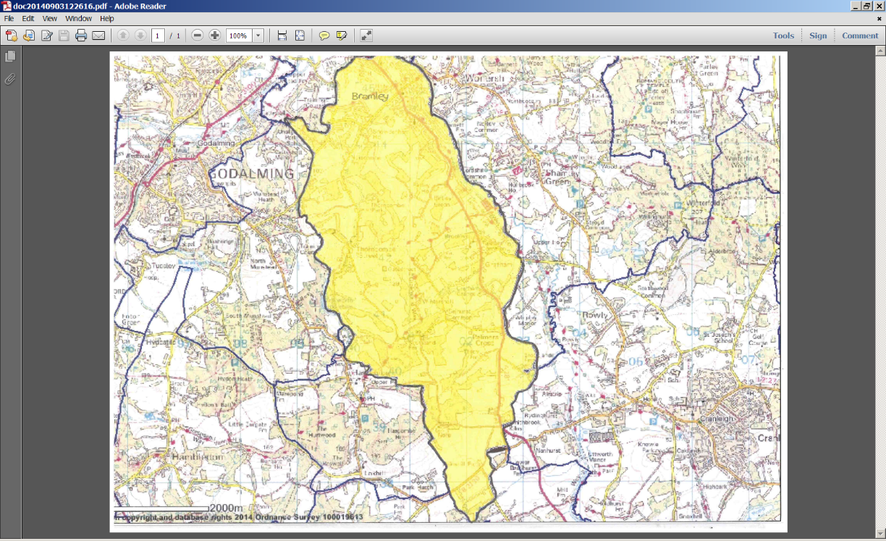

**Bramley Church of England Infant and Nursery School**

**Supplementary Information Form (SIF) for September 2024 Entry**

***To be completed only if you are applying under criteria 5 or 6. Applicants are required to return this form to the school office in order to prioritise applications in the case of oversubscription.***

Name of Child………………………………………………………………….……………

Name of Parent/Guardian ….………………………….............................................

Address.……………………………………………………………………………...……………………………………………………………………………….

………………...…………………………………………………….……………………………………………………...…………………………………………….

Telephone Number…………………………………………...............................................................

Email…………………………………………………………………………….....................

Are you a regular worshipper (see criteria 5 and 6) at a Church of England Church? Yes/No

Name of Church……………………………………………………………………

Signature of Parent/Guardian…………………………………………………

Date………………………………………….

**The following section must be completed by the applicant(s) in conjunction with the Church Vicar or other appropriate church leader.**

I confirm that the above named meets the ‘Regular Worshipper’ criterion of worshipping at least once a month over a period of at least one year immediately preceding the date of this application.

Name of Vicar…………………………………………………….........................................

Signature of Vicar…………………………………………………………………………………………

Date……….……………………………….

Church stamp or please attach a compliment slip.

**Please return this form to the School Office.**

**Bramley Church of England Infant School, Birtley Road, Bramley. GU5 0HX**